ANALYSIS OF SALES DATA (2014-2017)

By

Mohini Lonkar

CONTENTS

|  |  |  |
| --- | --- | --- |
| **SR. NO.** | **TITLE** | **PAGE NO.** |
| 1 | ABSTRACT | 3-3 |
| 2 | DATASET | 4-4 |
| 3 | DATA CLEANING | 5-6 |
| 4 | DATA VISUALISATION | 7-15 |
| 5 | DASHBOARD | 16-17 |
| 6 | STORY TELLING | 18-19 |

LIST OF FIGURES

|  |  |  |
| --- | --- | --- |
| **SR. NO.** | **TITLE** | **PAGE NO.** |
| 1 | Dataset Column | 6 |
| 2 | Dataset after cleaning (Column sorted) | 7 |
| 3 | Dataset after cleaning (Column added) | 8 |
| 4 | Sales & Profit Analysis for 2017 | 9 |
| 5 | Category wise Sales | 10 |
| 6 | Sales by Category & Subcategory | 11 |
| 7 | Scatter plot with Category & Sub-category Breakdown. | 11 |
| 8 | Aggregated Value for All Sales KPIs like. | 12 |
| 9 | Aggregated Value for All Sales KPIs like | 13 |
| 10 | Orders Returned for Each Product Category in 2016 | 13 |
| 11 | Sales /Quantity of product Category in Each Region | 14 |
| 12 | Top 5 Customer & Product by Sales | 15 |
| 13 | Sales By State | 15 |
| 14 | Sales & Profit Analysis by Customer | 16 |
| 15 | Number Of Orders Received by Quantity Bins | 17 |
| 16 | Sales Analysis by Dashboard | 18 |
| 17 | Sales & Profit Analysis for 2017, Category wise Sales | 20 |
| 18 | Sales by Category & Sub-Category, Sales & Profit Analysis by Customer | 20 |
| 19 | Sales KPI & Highlight Table | 21 |

ABSTRACT

DigiComp has expanded its presence across the globe, and the business wants to get an in-depth analysis of its sales to make better sales decisions. It has three major categories of clothes – Kids, Men, Women and selling their products in the Unites state. The analysis is based on the Order and return dataset from the year 2014 to 2017. The dataset focuses on the different categories of the cloths and its subcategories. As per the requirement, we have designed Tableau Dashboards by consolidating the data from multiple sources to carry out the sales analysis. Designed Tableau dashboard will help to sales department from DigiComp company to find the inefficient categories of the cloths where the company making losses or best product where company making good amount profit. Also, Company will know in which region/state company making good profit. With the help of this analysis sales department can decide rate of discount for each product to make the sales profitable throughout the year.

This will help the sales department to access the data from remote locations that would increase the overall timeliness, find inefficiencies, and make better decisions.

DATASET

The above data set shows cloth sale analysis data for 4 years from 2014-2017. It is a dataset with around 10k record and about 19 columns. Each row has a cloth order data, and it is one of the cleanest datasets that require minimum effort in data cleaning. For the California state and Los angles city, cloth sales are higher than other state. The kid’s clothing sales higher than women and men clothing sales. The column consists of the field such as Customer- who order the clothes, order date- date on which cloth order reported etc. The column gives us detail of sales status.

Also, we have one another dataset, which is giving the details of order returns. Which consist of Order Id and return status.

Below are all fields from the dataset:

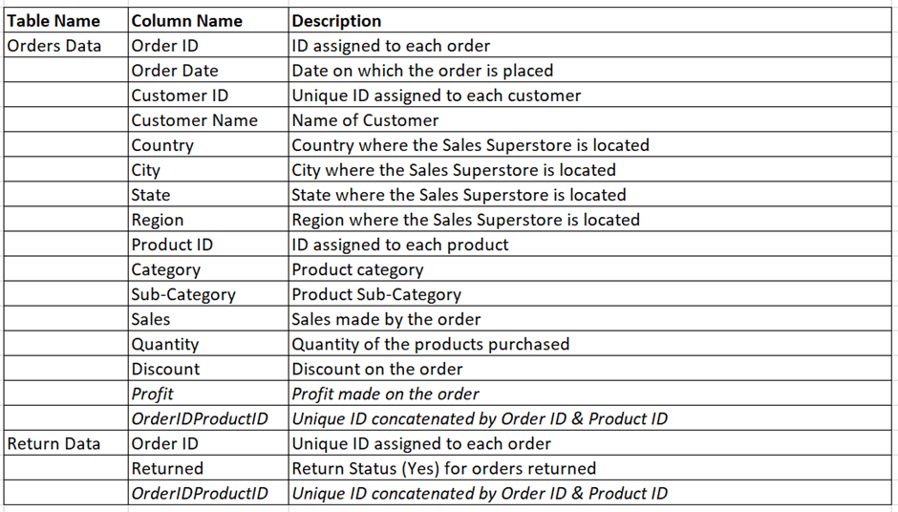

Fig-1 Dataset Columns.

The column gives us detail on the sales status.

DATA CLEANING

The dataset required very little cleaning to be done. The corrections made on the existing dataset are as follows:

After cleaning:

In the given data set, ‘Ship mode’ is extra column given so this column hides from dataset.

The given data set order date is not sorted cleaning data set order date are sorted.

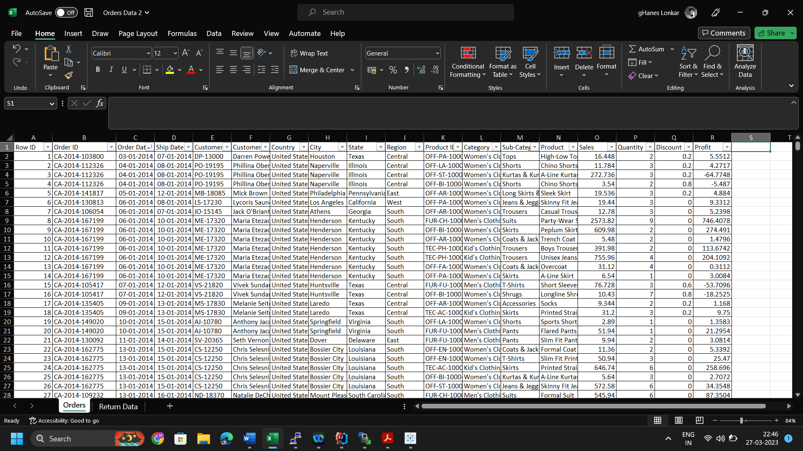

*Fig-2 Dataset after cleaning (column sorted).*

Addition of a new columns name profit ratio, Category or subcategory , Quantity bin which would help in portraying a better data visualization.

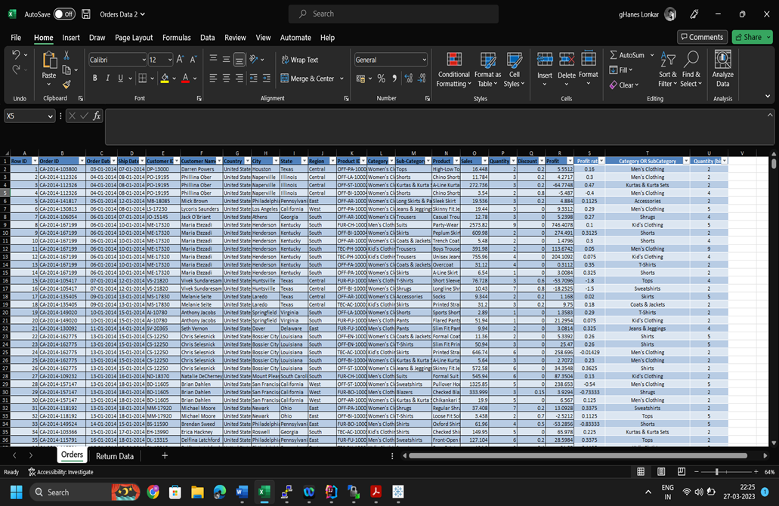

*Fig-3 Dataset after cleaning (column added).*

DATA VISUALISATION

The dataset has been analyses in such a manner that we get to know the total of sales done per year. These analysis helps us to understand how the sales and profit have functioned over the years.

The area and continuous line chart have been used for the visual representation and it shows us the variation in sales and profit monthly in 2017 year. It shows sale was the highest in November, and it was 118,448. Whereas the minimum sale was in March month, and it was 14752. Also, we are showing the profit made in 2017.

*Fig-4 Sales/Profit Analysis For 2017.*

The above graph provides us with the basic idea about sales and profit increase or decrease in 2017.

The packed bubble graph helps to understand which category has the maximum sales and which has minimum sales. The size of circle represents variation in sales (Highest to lowest).

Packed bubble chart to display data in a cluster of circles. Dimensions define the individual bubbles and measure define the size and color of the individual circles.

In the below chat we are showing category wise sales where we have sorted chart in ascending order. Chart shows overall sales was done maximum for the Kids category and less sales done for the Men’s category.

*Fig-5 Category Wise Sales.*

The above chart shows sales for the main categories but not showing sales for it’s subcategories, Hence we have plotted another graph using TreeMap chart. In which we are showing the sales for Category and its subcategories.

TreeMap to display data in nested Rectangles. TreeMap are a relatively simple data visualization that can provide insight in a visually attractive format. We used dimension to define the size and color of the individual’s rectangles. In this Treemap , both the size of rectangles and their color are determined by the value of sales. Greater sum of sales for each category and subcategory will show the tile with dark color and larger will be the size. Hence in the below graph first rectangular showing for the Kids category in that it is showing nested rectangles for it’s subcategories. Next, it is showing rectangles for Women its light in color, but it has more categories and Men have the dark rectangles, but it has less categories, so main rectangle is large for Women because Women category have the large sale than Men. But the subcategory wise sale is less in the Women category.

*Fig-6 Sales By Category& Sub-category.*

The above graph not showing profit for categories and subcategory Hence created scatter plot as below. In which, we are showing category wise sales and profit where on X-axis showing sales and Y-axis showing profit. We have provided option to break category into its subcategories.

*Fig-7 Scatter plot with Category & Sub-category Breakdown.*

To break category into its subcategory needs to click on category. In the above graph, kids’ category is brock into its subcategory.

The text table more values row and one or more value column. The easiest way to picture a text table of sales expense date.

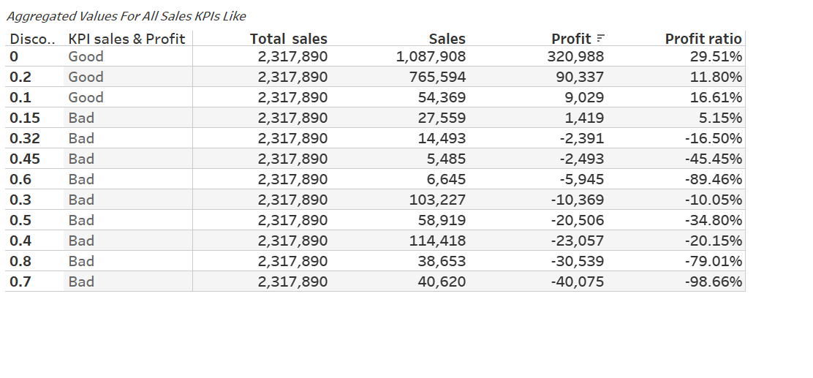

*Fig-8 Aggregated Value for All Sales KPIs like.*

It creates KPI (key performance indicator) if measurable value that show effectively a company is achieving key business objective. The KPI use Total sales created calculate filed and use aggregated sum of sales Then Total sales calculate table create.

The text table shows comparison Total sales by discount, sales, profit, profit ratio. Digi Comp is a global enterprise in this company Discount increase sales increase or decrease by showing text table. That chart indicate Discount increase profit and profit ratio decreases.

KPI Sales & Profit indicate that Sales >50,000 & Profit>0 Then it is good for company, But Sales are less 50,000 and profit is negative then it is bad for company.

Highlight table display data in text table. Using color, they speed up how you identify the most important numbers within a range of values.

The highlight table created by placing Order date (Year & Quarter) on the columns shelf and State & Category on row shelf to show sales & profit. Below table show sales for all the quarter for their respective years across state and category in text and profit is highlight by using color. If the Profit is negative then text box color is red and profit is positive text box color is green.

*Fig-9 Sales For All Quarter Of All The Year Across State & Category AS a Highlight Table.*

Compony should be aware of their number of returned orders hence we have blend dataset of returned orders to Order dataset and created one bar chart to show details of returned order for the 2016. This detail shows number of returned orders for the product by its category.

*Fig-10 Orders Returned for Each Product Category in 2016.*

When we need to compare data point, it is often easier to see the comparison of stack bar chart. In the below chart showing sales and quantity region wise and each stack showing category wise sales and Quantity.

In south region Quantity and sales are less as compare other region and for west region sale is highest and number of quantities is also higher.

*Fig-11 Sales /Quantity of product Category In Each Region*

Bar chart showing Top 5 product and Top 5 customer by sales wise. In this chart by using filter method. A bar chart represent data in rectangular forms length of the bar proportional to the sales. Highest length of the bar that show highest sales. Top 5 customer name by sales highest bar length they show highest sales below chart showing Sean miller highest bar length thus highest sale as compare other customer name. Top product by sales highest **bar length** they show highest sales below chart showing Formal suit highest bar length thus highest sale as compare other product.

*Fig-12 Top 5 Customer & Product by Sales*

Above chart does not show Country and State wise sales. Since a geographical role Country and State wise sales by using Map chart. It is highly interactive when you want to plot geographical data on a plot. In the map chart circle size, more and color is green hence highest sales in state. The map chart circle size less and color is red hence lowest sales in state.

*Fig-13 Sales By State*

In this scatter plot is simple only show sales and profit analysis by customer name.

Above scatter plot is advance category breakdown and show sub-category data. Different circle color show different customer name. Circle size more sales are high, and profit shows by text. Circle size less sales are low.

S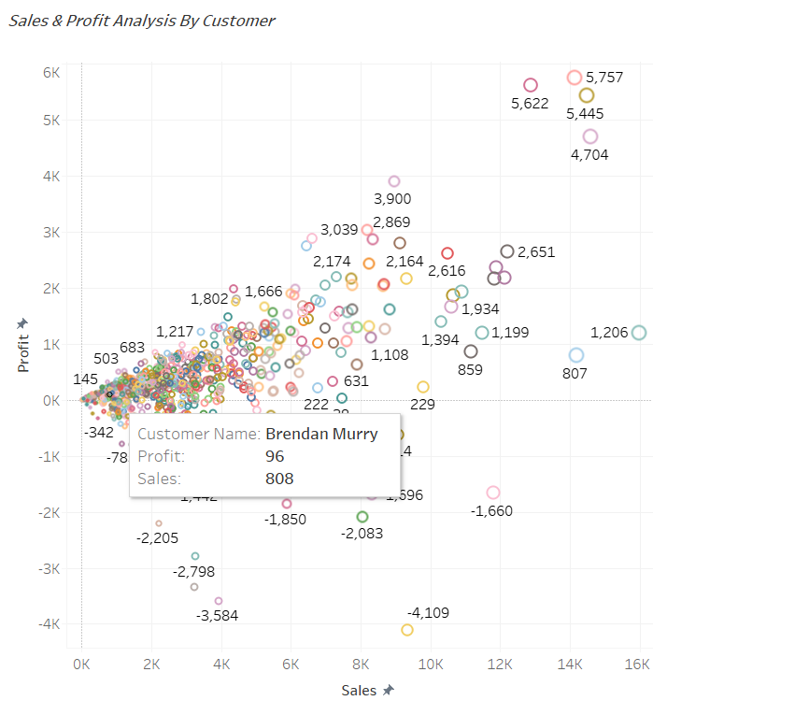

*Fig-14 Sales & Profit Analysis by Customer*

As we can see in the below graph, the histogram has a bin field on the x-axis. The histogram is so created that it drops values of quantities per order in bins of size 2. That means, all the quantities that fall under 0 to 2 range will occupy the 0 to 2 bins.

In this chart looks like a bar chart but groups value for a continuous measure into ranges, or bins. A histogram displays Quantity data by grouping data into bins of equal width.

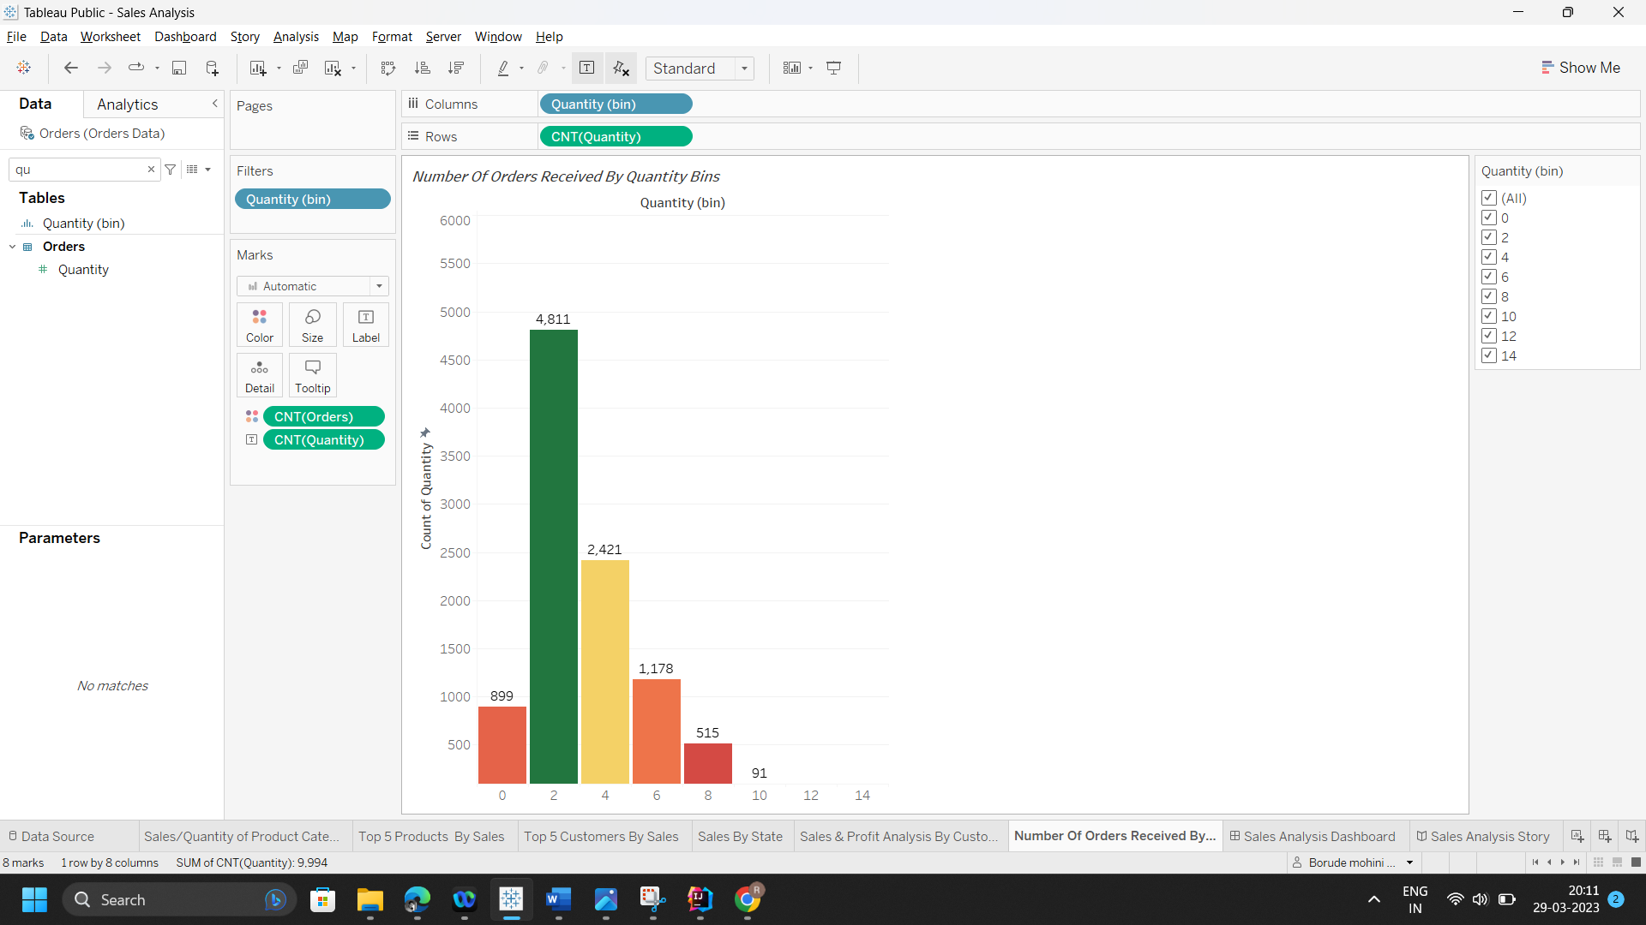  
*Fig-15 Number Of Orders Received By Quantity Bins.*

DASHBOARD

Clothing company Digital Comp. generates lots of order data each year. It will be very difficult to analyse profit, sales of company for Admin persons. To make it easier we have designed Sales analysis dashboard which will help Admin persons to summarize sales, profit of the company by filtering the dashboard on different criteria.

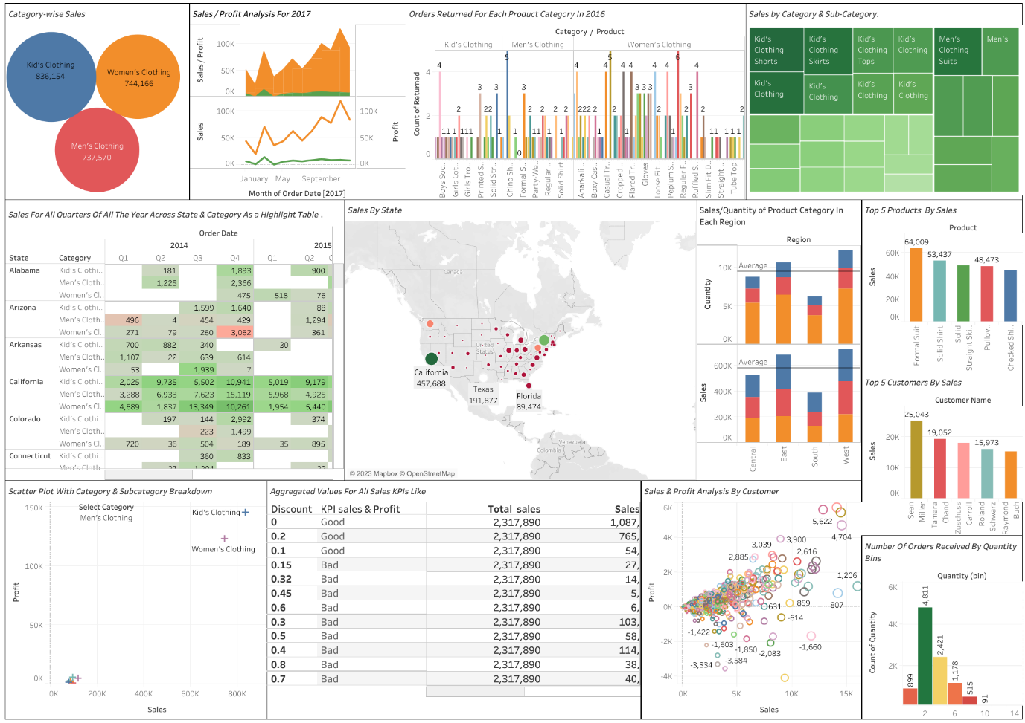

*Fig-16 Sales Analysis By Dashboard.*

A dashboard is a collection of several views, letting you compare a variety of data simultaneously at a same time. The sales analysis data has been analysed based on sales and profit by category wise and its subcategory. Combine all worksheet on single dashboard by using floating. Dashboards are useful for monitoring, measuring, and analysing relevant data in key areas. Using dashboard, we can analyse sales and profit for the different categories and subcategories also we can filter data based on the state, order date etc.

In the dashboard, different sections show different data like the area and line chart show sales and profit data for 2017-year and showing data month wise.

Packed Bubble chart show sale for each category. From this anyone can make the analysis like for which category company making high sale.

Highlight table show sales and profit for each state and each category in the United state for all years from 2014 -2017 quarters wise. Tree map chart showing sales by category and subcategory.

Horizontal bar chart shows, how many orders returned for the categories and it’s subcategories. To do this we have blend the return order data with orders data. By using this graph, people from higher authority in the company can find for which categories or its subcategories maximum orders are getting returned.

Map chart is interactive visualisation for country and state wise sales where the size for circle defines number of sales. Increasing sales will increase the size of circle.

Stack bar chart show region wise sales & quantity and each stack show categories. Bar chart showing top 5 product for which maximum sale done and top 5 customer for which maximum sale done for all past years. From this analysis company will know the best product for the company for which higher sale is done.

Two scatter plots are added in the dashboard. One is simple and another is advance category breakdown and visualise sub categorical data. Simple scatter plot shows sales and profit done for each customer.

A Key Performance Indicator is a measurable value that shows how effectively a company is achieving key business objectives. At a high level, we are showing where the discounted price is good or not for the company by considering the sales and profit.

KPI Indicator visualise data but use KPI (key performance indicator) table shows sales done grouped by discount rate and compared with total sales done for the company. Another table create it indicate that sales is greater than 50000 and profit is greater than zero then show good otherwise show bad.

Last one is histogram graph by using bin. bin is container it stores numerical quantity data. It shows number orders falling under each bin. Suppose one order is for 4 quantities. so that, order will fall under the bin of 4.

STORY TELLING

Story telling dataset consist of sales analysis data from 2014-2017 year. Story contains a sequence of worksheet or dashboard or both that work together to convey certain information. Date on which sales was reported, order date, customer name, Product, category, customer id, profit, Sub-category, State. In this story contains a sequence of worksheet in the following.

Sales and profit wise order date 2017 in month by using area and line graph It tells us by what sales and profit increase or decrease. Category wise sale in sort order by using packed bubble chart.

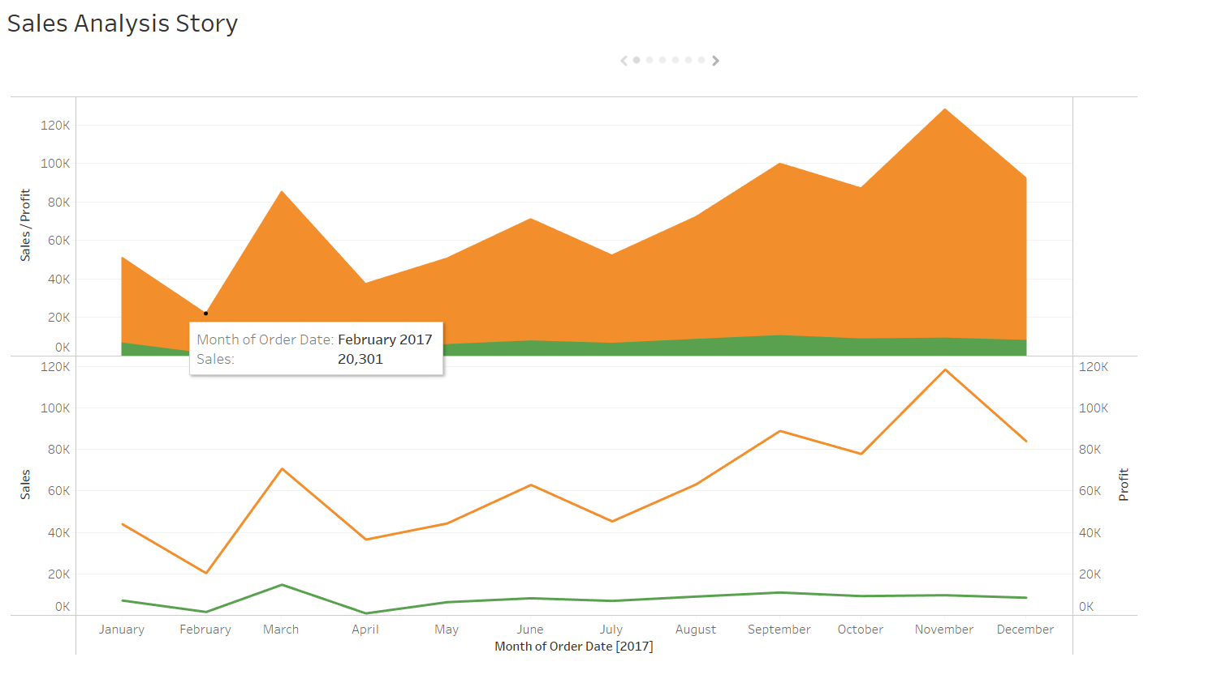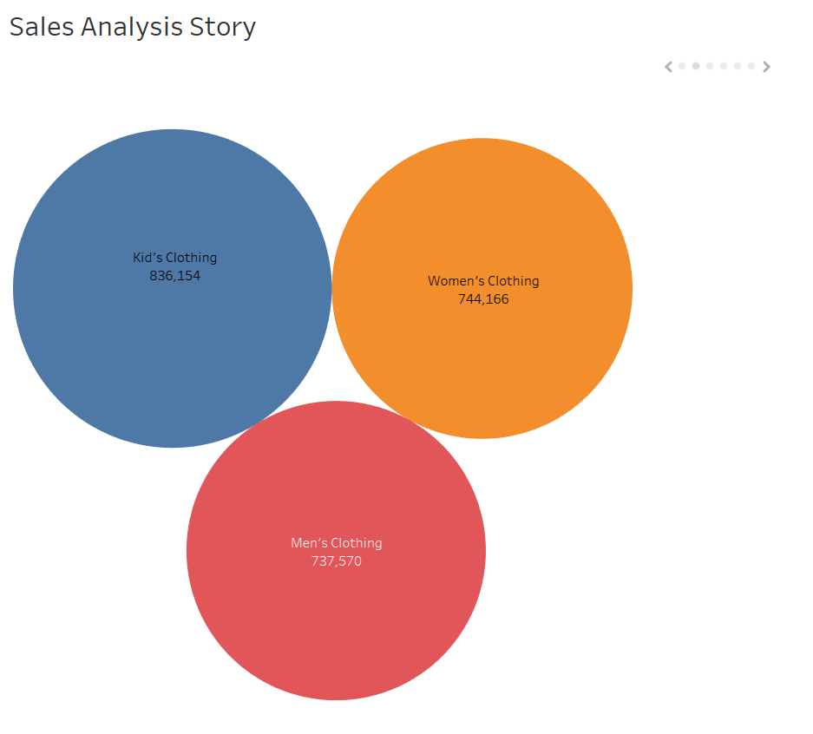

*Fig-17 Sales & Profit Analysis for 2017, Category wise Sales.*

Tree map chart showing category and subcategory wise sales and profit. Once we have the knowledge about sales and profit increase or decrease. Scatter plot shows customer name wise sales and profit. Use scatter plot to visualise relationships between numerical variables.

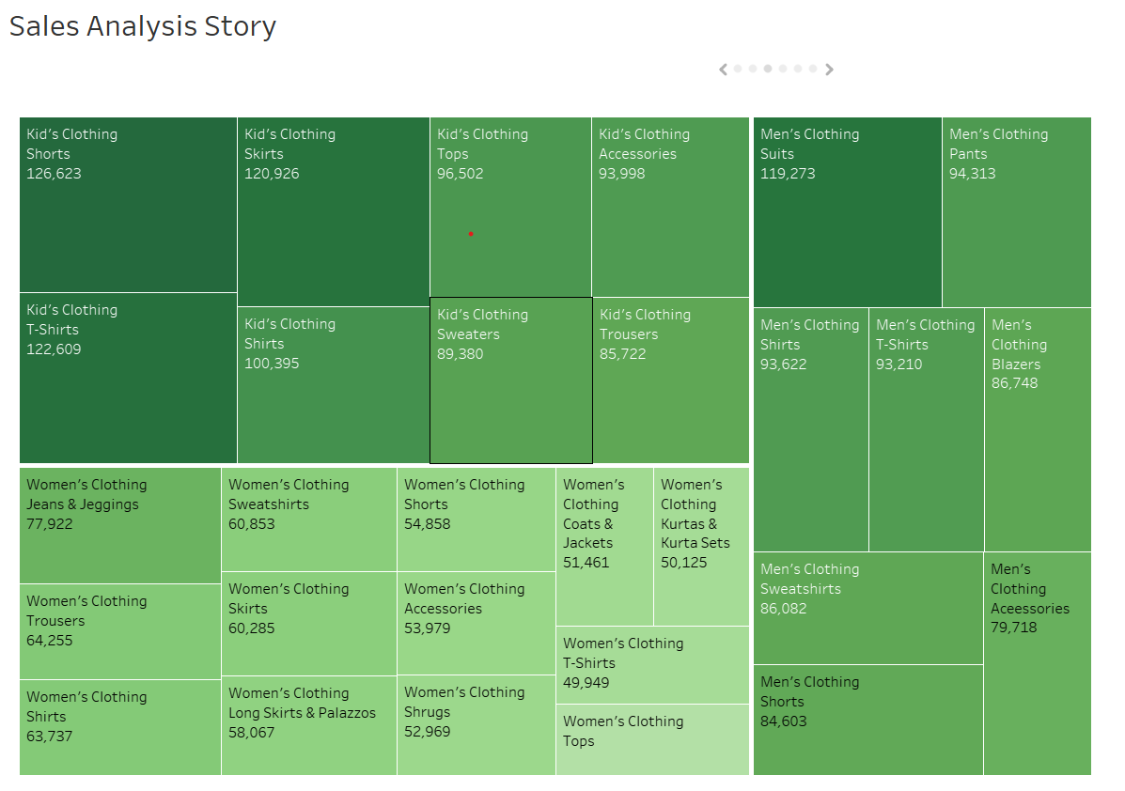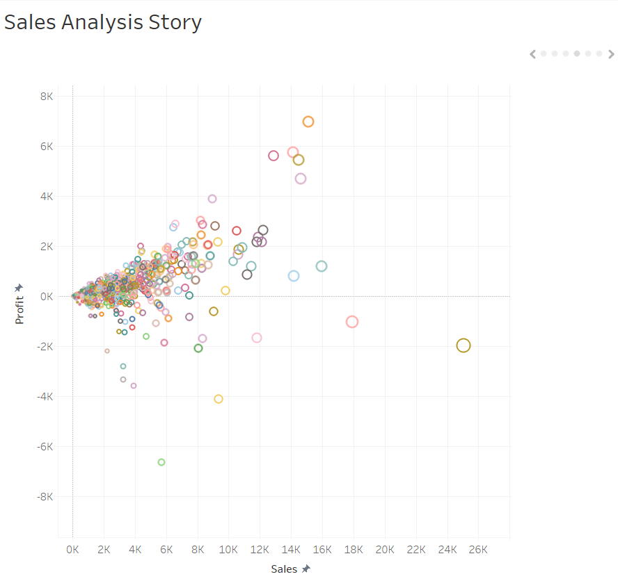

*Fig-18 Story Telling- Sales by Category & Sub-Category, Sales & Profit Analysis by Customer.*

Text table showing discount impacting the sales & profit. Generally, increasing in discount rate decreases profit of the company.

In the highlight table, showing sales and profit for each quarter of all years from 2014-2017 and data is based on the state. Highlight table more visualize data, as compared to other.

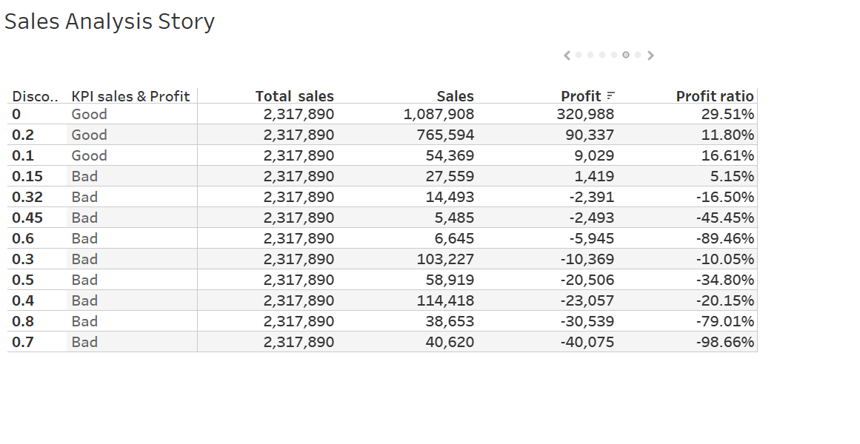

*Fig-19 Sales KPI & Highlight Table.*